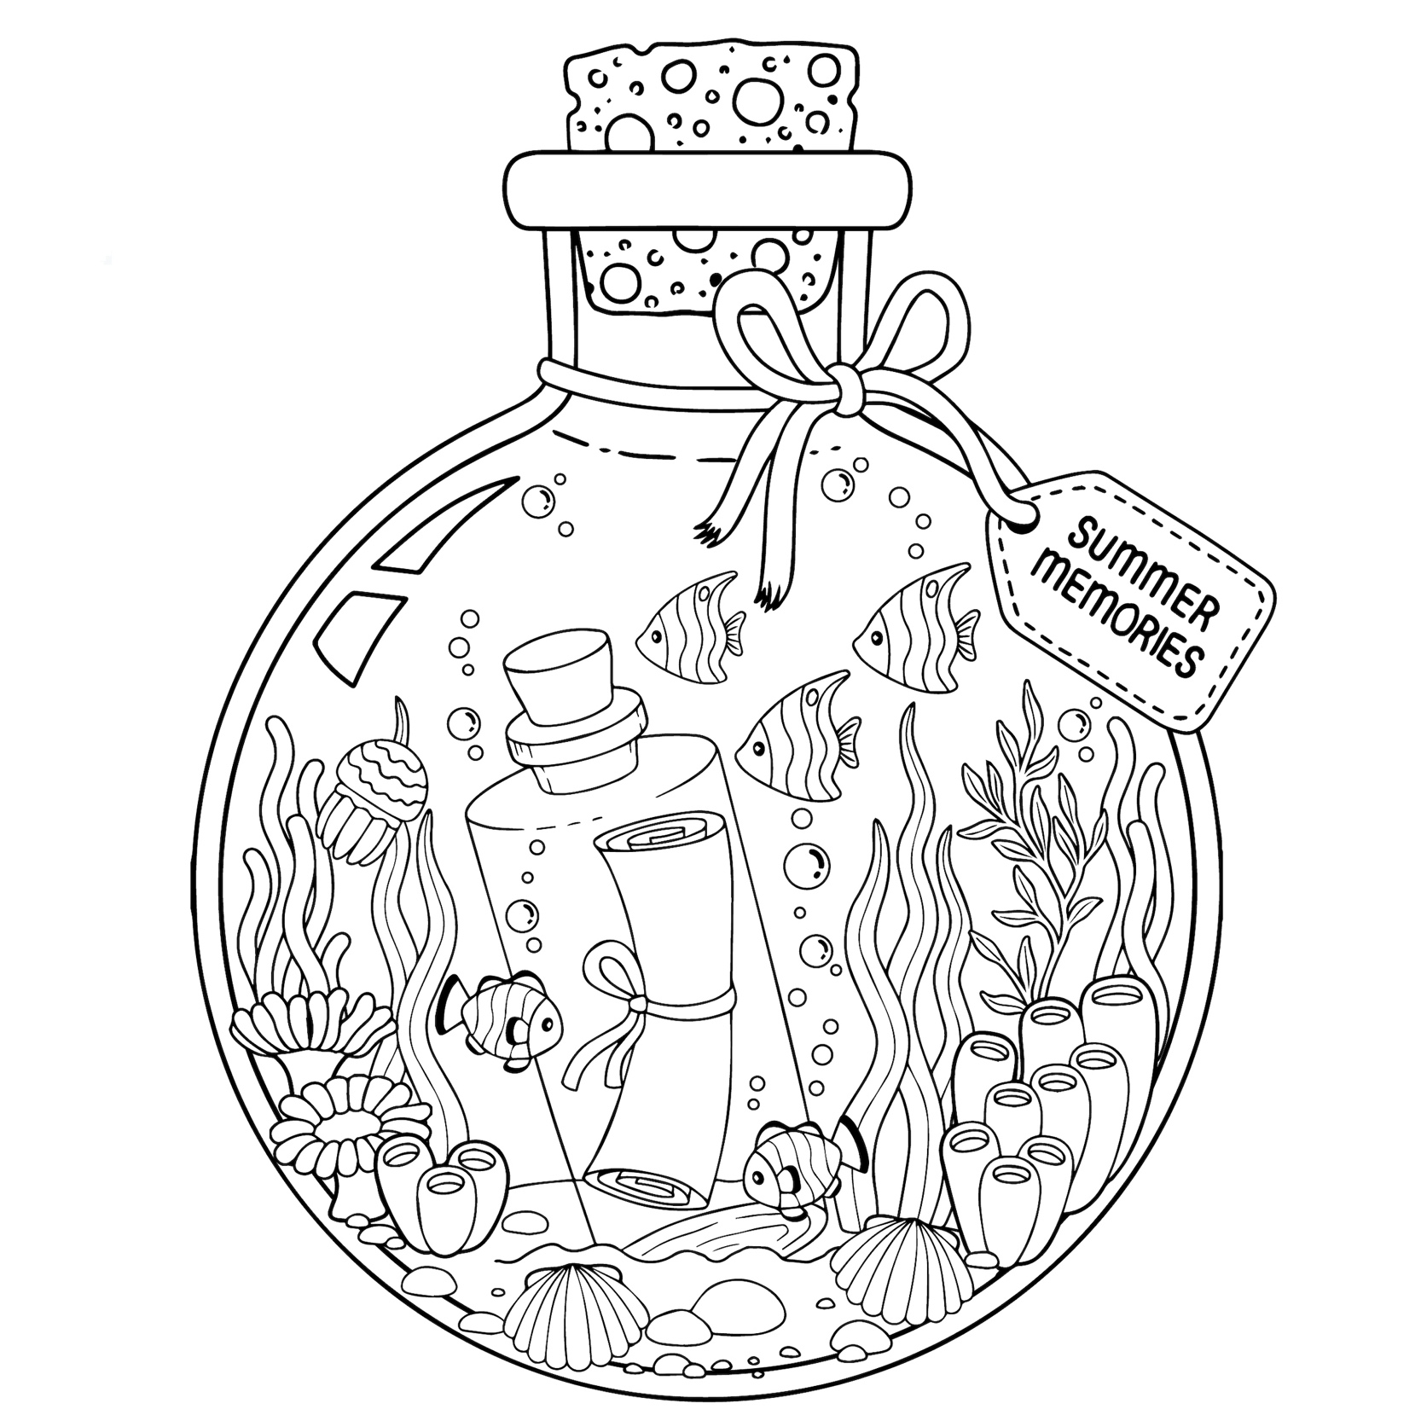

Enjoy this fun coloring page inspired by my books set on the coast.
SAND DOLLAR COVE also airing on Hallmark Channel
THE SHELL COLLECTOR also streaming on Fox Nation

COLOR TODAY A BEAUTIFUL BEACH READ DAY!

