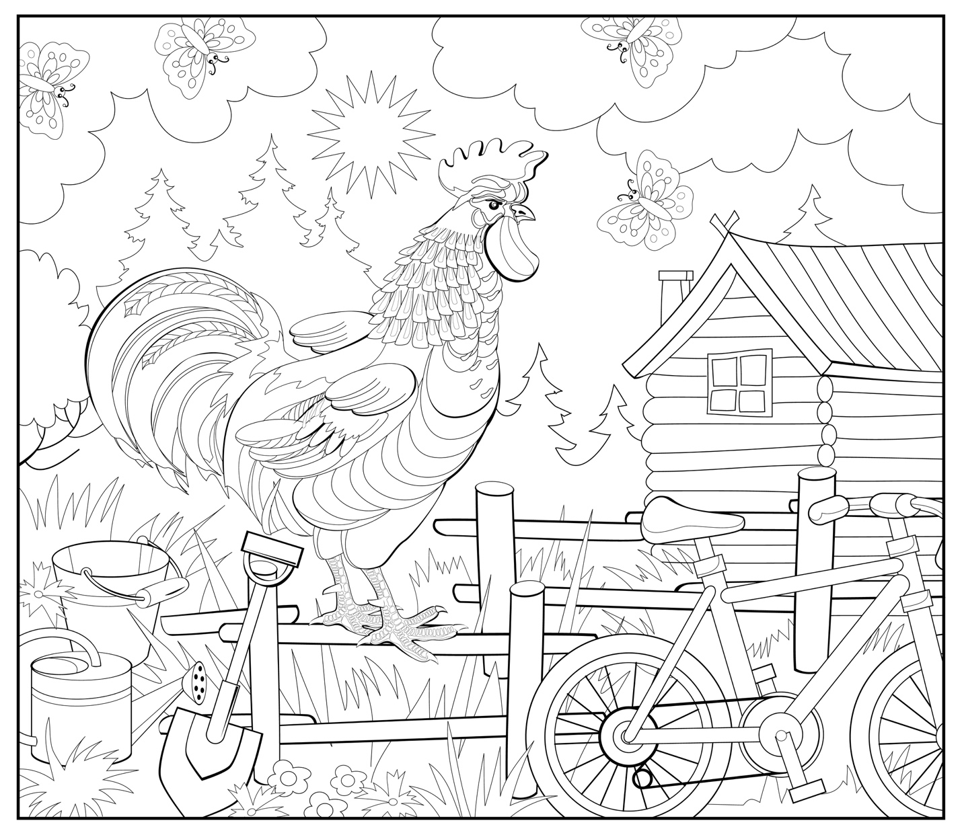

Enjoy this fun coloring page inspired by the simple country living like that in Antler Creek, NC in my books Christmas Angels and released in 2022, What Remains True. It was so much fun creating this small town and all the people who were born or brought to it.

I’d love to see your finished page. If you post it on social media, please tag me and let me know which ones you like the best.

COLOR TODAY A BEAUTIFUL AND JOY-FILLED DAY!

